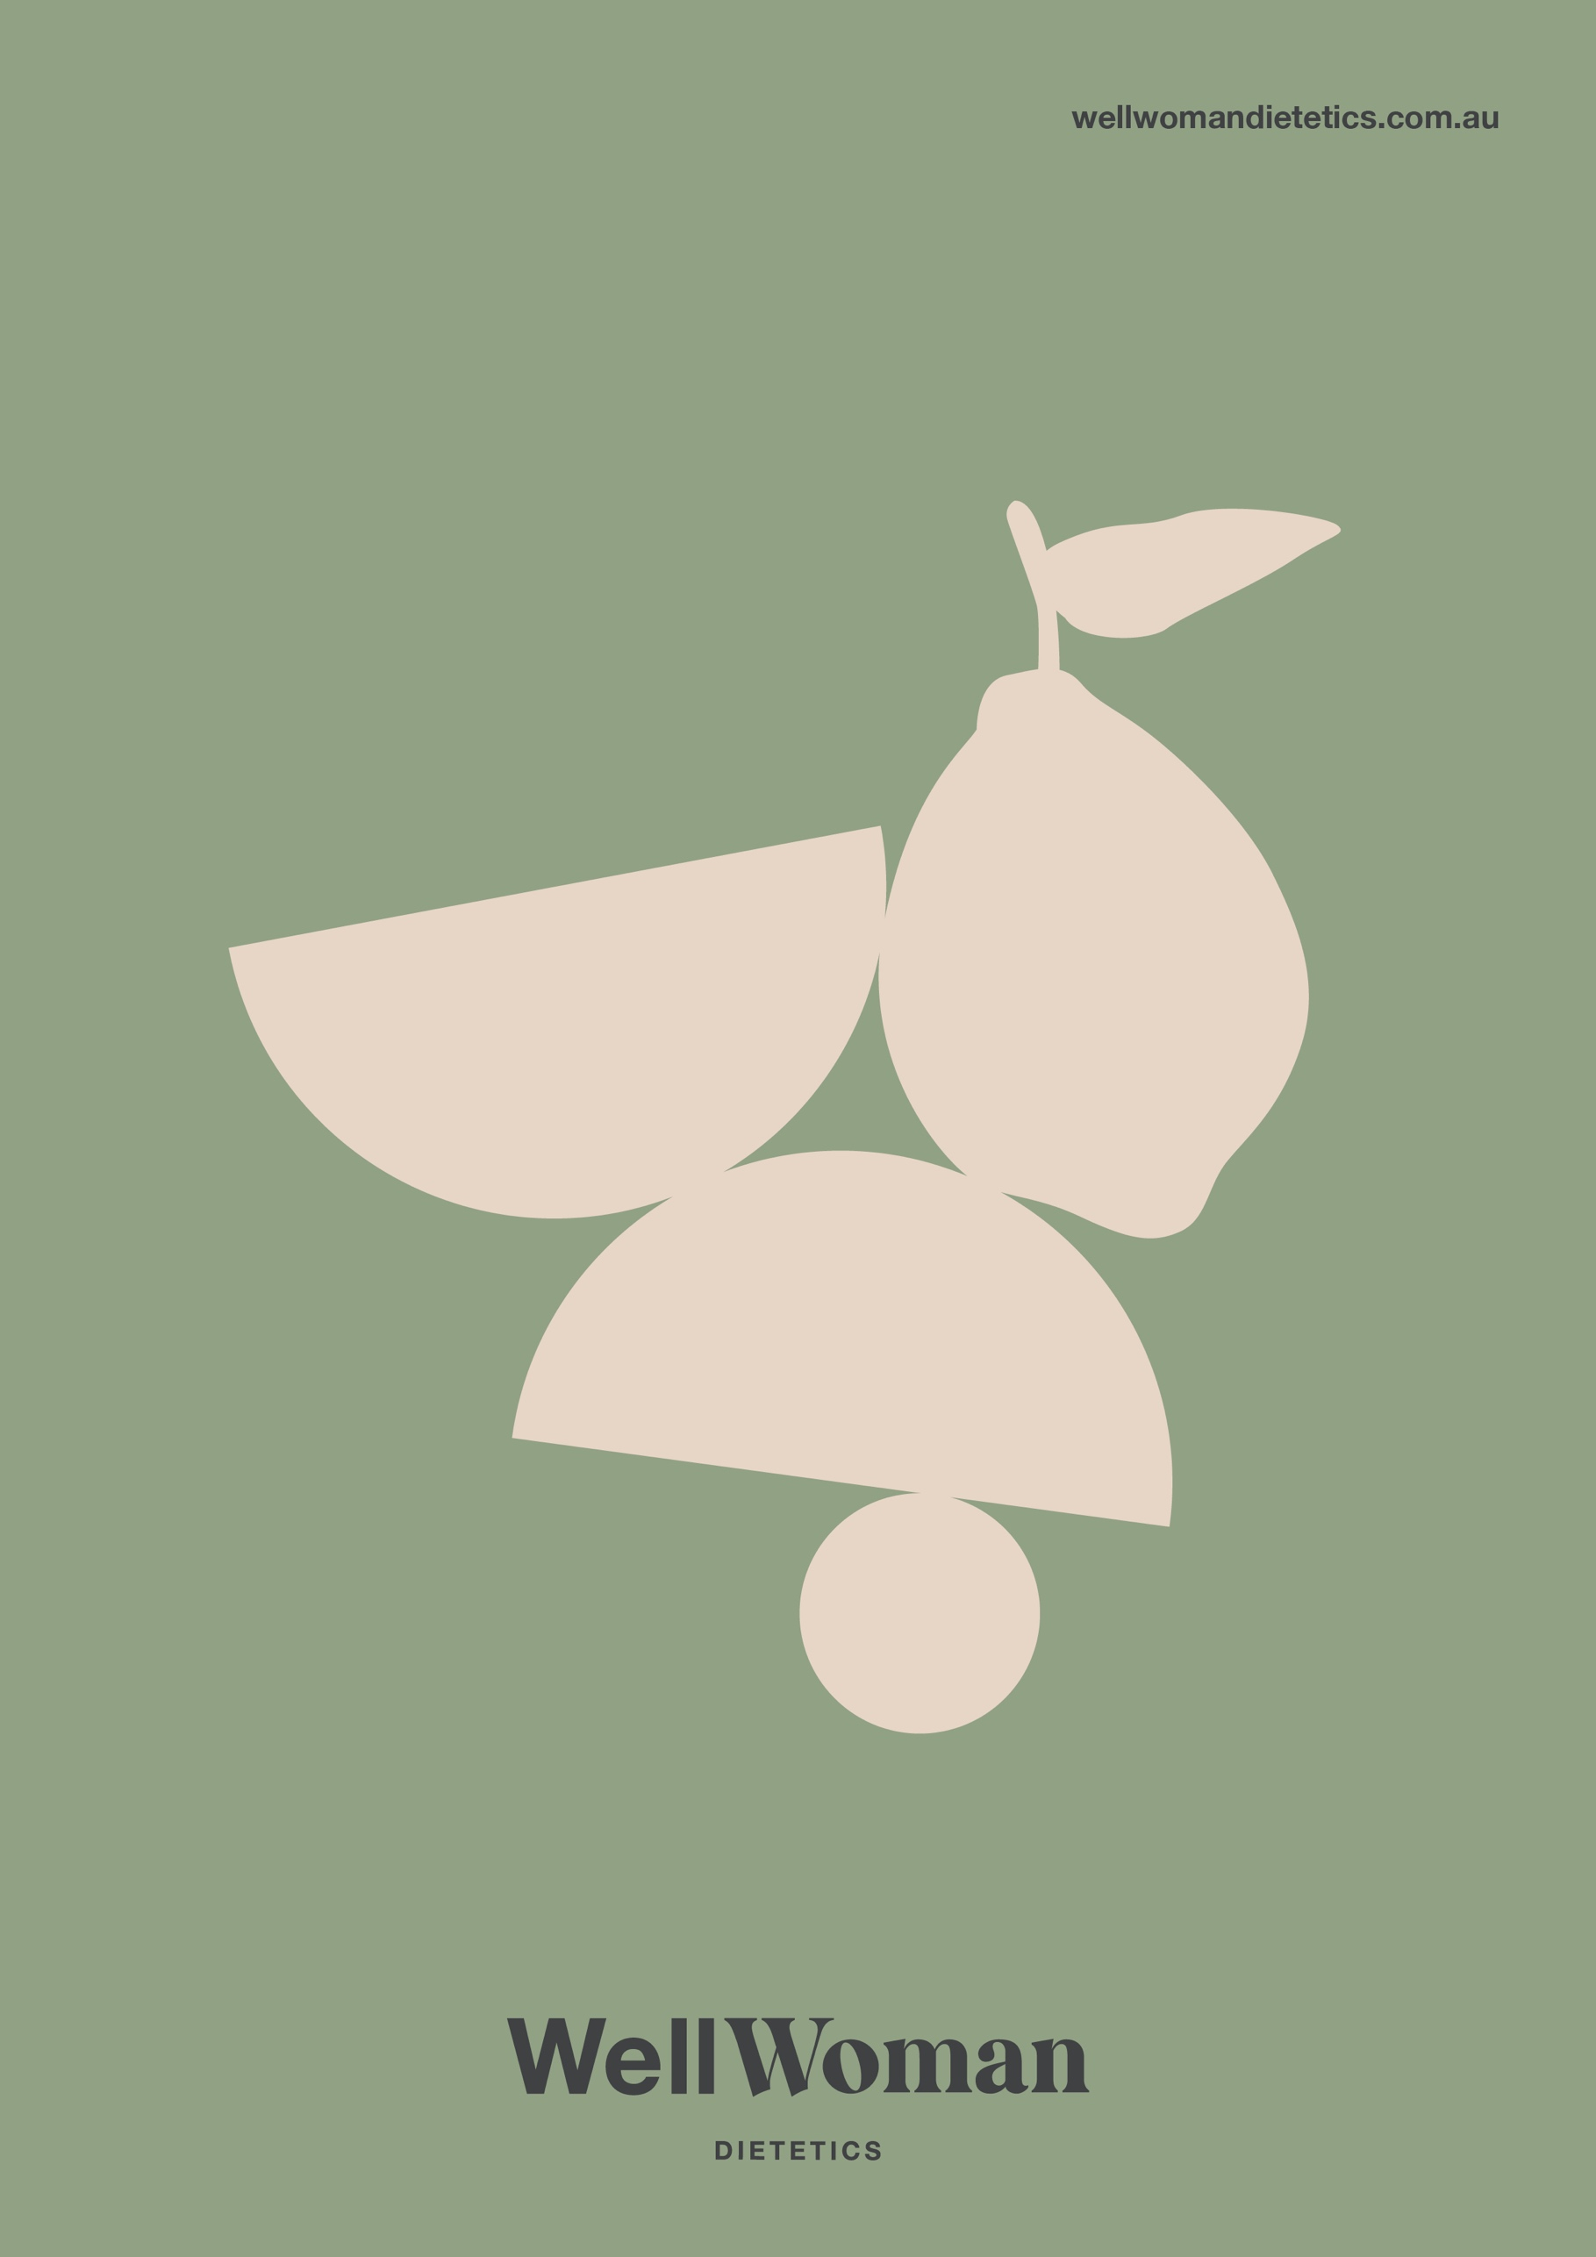
Website Terms and Conditions

Well Woman Dietetics – Website Terms and Conditions of Use

About the Website
  - Welcome to www.wellwomandietetics.com.au. The Website provides you with an opportunity to book services that have been listed on the Website. The Website provides this service by way of granting you access to the content on the Website.
  - The Website is operated by Well Woman Dietetics (ABN: 33 242 895 229) trading as Well Woman Dietetics. Access to and use of the Website, or any of its associated Services are provided by Well Woman Dietetics. Please read these terms and conditions carefully. By using, browsing and/or reading the Website, this signifies that you have read, understood and agree to be bound by the Terms. If you do not agree with the Terms, you must cease usage of the Website, or any of Services, immediately.
  - Well Woman Dietetics reserves the right to review and change any of the Terms by updating this page at its sole discretion. When Well Woman Dietetics updates the Terms, it will use reasonable endeavours to provide you with notice of updates to the Terms. Any changes to the Terms take immediate effect from the date of their publication.

Acceptance of the Terms
- You accept the Terms by remaining on the Website. You may also accept the Terms by clicking to accept or agree to the Terms where this option is made available to you by Well Woman Dietetics in the user interface.

Bookings and Cancellations for Services
  - Well Woman Dietetics requires all bookings for the Services to be made via the booking system provided.
  - If you choose to create an account with the Booking System, you acknowledge and agree to be bound by the Terms and Conditions of Use, Privacy Policy and other relevant legal documentation provided by the Booking System.
  - Once you have made a booking for the Services, you will be required to make payment of the purchase price via credit card, or other payment method as advised from time to time. Payment of the Purchase Price at the time of booking to confirm your booking, or your booking will be cancelled.
  - You must notify Well Woman Dietetics of an intention to cancel the Services as soon as practicable through e-mail to hello@wellwomandietetics.com.au and abide by the following the Cancellation Policy.
  - Well Woman Dietetics understands that things change, and therefore if you need to make a request to alter your booking time you agree to provide at least 48 hours notice. Unfortunately, if you have to make changes within 48 hours of your scheduled session, you will forfeit your booking time and fee.
- Services Disclaimer
  - Well Woman Dietetics will maintain Accredited Practising Dietitian status.

  - You agree that when you purchase the Services, you are solely responsible for creating and implementing your own physical, mental and emotional well-being, decisions, choices, actions and results arising out of or resulting from Well Woman Dietetics relationship with you, its educational materials and interactions with you. As such, you agree that Well Woman Dietetics is not and will not be liable or responsible for any actions or inaction, or for any direct or indirect result of any Services it provides.

  - You understand that the Services are not a substitute for medical attention, examination, diagnosis or treatment. Additionally, the Services are not to be used as a substitute for professional psychology, psychiatric or other mental health care. It is your exclusive responsibility to seek such independent professional guidance as needed.

  - You agree to release and discharge Well Woman Dietetics from and against all claims arising out of or in connection with provision of the Services. This release includes but is not limited to any claim for personal injury, damages and death of any participant which has received a Service from Well Woman Dietetics.

- Information Disclaimer
  - Any information, advice, content or documentation provided on the Website, through the Services, social media accounts, blog or on any other related platform do not constitute professional, medical or psychological or other advice and are provided for general information and guidance purposes only.
  - All care is taken in the preparation of the information and published materials on the Website, through the Services, social media accounts, blog, or on any other related platform. Well Woman Dietetics does not make any representations or give any warranties about its accuracy, reliability, completeness or suitability for any particular purpose.
  - To the extent permissible by law, Well Woman Dietetics will not be liable for any expenses, losses, damages (including indirect or consequential damages) or costs which might be incurred as a result of the information being inaccurate or incomplete in any way and for any reason or your reliance on the information, advice or documentation on the Website, through the Services, social media accounts, blog, or on any other related platform.

Copyright and Intellectual Property
  - You acknowledge that the Website, the Purchase Services, Well Woman Dietetics name, services, and any logos, designs, text, graphics, software, content, files, materials, and any other intellectual property rights contained therein, including without limitation, any copyrights, patents, trademarks, proprietary or other rights arising thereof, are owned by Well Woman Dietetics or its affiliates, licensors, or suppliers whether displayed on the Website, social media accounts, blog or on any other related platform.
  - You hereby indemnify and agree to keep indemnified Well Woman Dietetics against all liability, losses or expenses incurred by Well Woman Dietetics in relation to or in any way directly or indirectly connected with any breach of intellectual property rights of Well Woman Dietetics or any third party by you or your agents.
  - You may not, without the prior written permission of Well Woman Dietetics and the permission of any other relevant rights owners: broadcast, republish, up-load to a third party, transmit, post, distribute, show or play in public, adapt or change in any way the Content or third party content for any purpose. This prohibition does not extend to materials on the Website, which are freely available for re-use or are in the public domain.

Privacy
- Well Woman Dietetics takes your privacy seriously and any information provided through your use of the Website and/or the Purchase Services are subject to Well Woman Dietetics Privacy Policy.

General Disclaimer
  - You acknowledge that Well Woman Dietetics does not make any terms, guarantees, warranties, representations or conditions whatsoever regarding the Services other than provided for pursuant to these Terms.
  - Nothing in these Terms limits or excludes any guarantees, warranties, representations or conditions implied or imposed by law, including the Australian Consumer Law (or any liability under them) which by law may not be limited or excluded.
  - Subject to this clause, and to the extent permitted by law:
    - all terms, guarantees, warranties, representations or conditions which are not expressly stated in these Terms are excluded; and
    - Well Woman Dietetics will not be liable for any special, indirect or consequential loss or damage (unless such loss or damage is reasonably foreseeable resulting from our failure to meet an applicable Consumer Guarantee), loss of profit or opportunity, or damage to goodwill arising out of or in connection with the Purchase Services or these Terms (including as a result of not being able to use the Purchase Services or the late supply of the Purchase Services), whether at common law, under contract, tort (including negligence), in equity, pursuant to statute or otherwise.
  - Use of the Website, the Services of Well Woman Dietetics is at your own risk. Everything on the Website, the Purchase Services of Well Woman Dietetics, are provided to you on an "as is" and "as available" basis, without warranty or condition of any kind. None of the affiliates, directors, officers, employees, agents, contributors, third party content providers or licensors of Well Woman Dietetics make any express or implied representation or warranty about its Content or Purchase Services (including Purchase Services of Well Woman Dietetics) referred to on the Website. This includes (but is not restricted to) loss or damage you might suffer as a result of any of the following:
    - failure of performance, error, omission, interruption, deletion, defect, failure to correct defects, delay in operation or transmission, computer virus or other harmful component, loss of data, communication line failure, unlawful third party conduct, or theft, destruction, alteration or unauthorised access to records;
    - the accuracy, suitability or currency of any information on the Website, the Purchase Service, or any of its Content related products (including third party material and advertisements on the Website);
    - costs incurred as a result of you using the Website, the Purchase Services or any of the Services;
    - the Content or operation in respect to links which are provided for your convenience;
    - any failure to complete a transaction, or any loss arising from e-commerce transacted on the Website; or
    - any defamatory, threatening, offensive or unlawful conduct of third parties or publication of any materials relating to or constituting such conduct.

User Generated Content

If you choose to contribute any content to the Website or any other platform operated by Well Woman Dietetics, you are solely responsible for it. This includes comments, reviews, tweets, posts, photos, pictures, images, videos, materials or other user-generated content or information.
  - By contributing content to the Website, you grant Well Woman Dietetics a royalty-free, non-exclusive license to use Your Content in any way that it chooses. This may include the use of your photos or video on other parts of the Website, advertising, promotions or social media accounts held by Well Woman Dietetics.
  - Additionally, if you post Your Content with any personal information including identifying information such as location or name, you agree Well Woman Dietetics can use that information with Your Content for advertising and promotional purposes, or any other business purpose
  - You confirm you own or have the right to use any copyright material included in Your Content (including replies to Well Woman Dietetics social media posts, reviews, music, photos, quotes and excerpts of audio or video), that you have permission of anyone appearing or performing in Your Content and that you are not infringing any third-party rights by submitting the content to Well Woman Dietetics. You also confirm you have, where appropriate, sought the consent of the parent or guardian of any person under the age of 18 who is featured in Your Content.
  - Please ensure you keep your own copies of Your Content as Well Woman Dietetics may not archive, store or back-up Your Content nor continue to make Your Content accessible online.
  - Well Woman Dietetics will endeavour to provide you with an appropriate credit when using Your Content on Well Woman Dietetics platforms, though you understand and agree this may not always be possible.
  - Well Woman Dietetics reserves the right to remove Your Content at any time. Your Content must not be malicious, libellous, false, inaccurate, threatening, abusive, obscene, defamatory or racially, sexually, religiously or otherwise objectionable and offensive.

Limitation of Liability
  - Well Woman Dietetics total liability arising out of or in connection with the Purchase Services or these Terms, however arising, including under contract, tort (including negligence), in equity, under statute or otherwise, will not exceed the most recent Purchase Price paid by you under these Terms or where you have not paid the Purchase Price, then the total liability of Well Woman Dietetics is the resupply of information or Purchase Services to you.
  - You expressly understand and agree that Well Woman Dietetics, its affiliates, employees, agents, contributors, third party content providers and licensors shall not be liable to you for any direct, indirect, incidental, special consequential or exemplary damages which may be incurred by you, however caused and under any theory of liability. This shall include, but is not limited to, any loss of profit (whether incurred directly or indirectly), any loss of goodwill or business reputation and any other intangible loss.
  - Well Woman Dietetics is not responsible or liable in any manner for any site content (including the Content and Third Party Content) posted on the Website or in connection with the Purchase Services, whether posted or caused by users of the website of Well Woman Dietetics, by third parties or by any of the Purchase Services offered by Well Woman Dietetics.

Indemnity
  - You agree to indemnify Well Woman Dietetics, its affiliates, employees, agents, contributors, third party content providers and licensors from and against:
    - all actions, suits, claims, demands, liabilities, costs, expenses, loss and damage (including legal fees on a full indemnity basis) incurred, suffered or arising out of or in connection with any Content you post through the Website;
    - any direct or indirect consequences of you accessing, using or transacting on the Website or attempts to do so and any breach by you or your agents of these Terms; and/or
    - any breach of the Terms.

