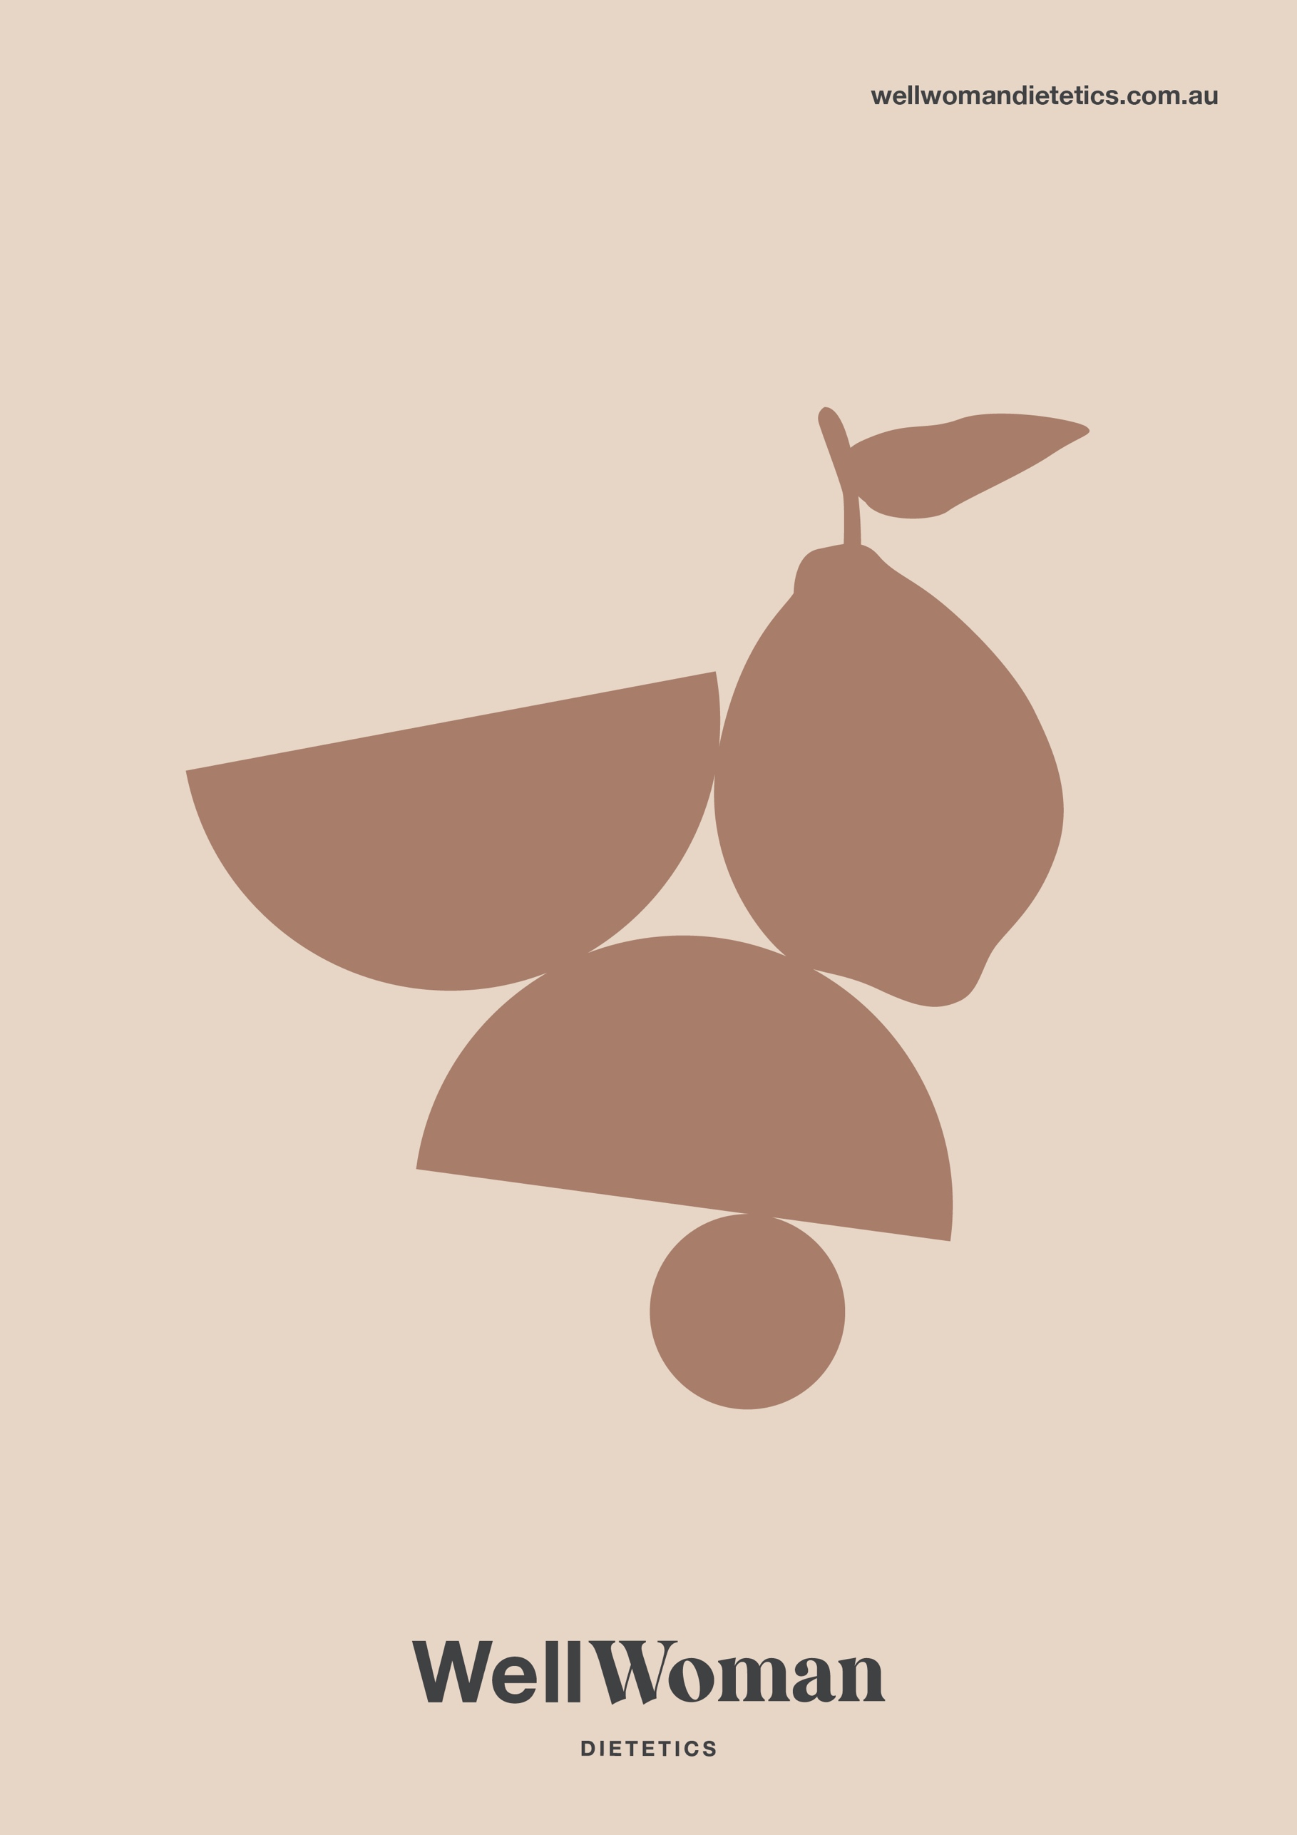
Privacy Policy

Well Woman Dietetics - Privacy Policy

- We respect your privacy
  - Well Woman Dietetics respects your right to privacy and is committed to safeguarding the privacy of our customers and website visitors. We adhere to the Australian Privacy Principles contained in the Privacy Act 1988 (Cth). This policy sets out how we collect and treat your personal information.
  - "Personal information" is information we hold which is identifiable as being about you.

Collection of personal information
  - Well Woman Dietetics will, from time to time, receive and store personal information you enter onto our website, provided to us directly or given to us in other forms, including through client intake forms and during appointments. When you complete our client intake form, you provide consent for Well Woman Dietetics to access and use your personal information so we can provide you with the best possible advice.

  - The information we will collect about you includes your name, date of birth, address, phone number, email address, health information including your medical history, medications, allergies, adverse events, immunisations, social history, family history and risk factors, health fund details to enable us to provide you with the best services, to send information and provide updates to you.

  - You may also provide basic information such as your name, phone number, address and email address to enable us to send information, provide updates and process your service order. We may collect additional information at other times, including but not limited to, when you provide feedback, when you provide information about your personal or business affairs, change your content or email preference, respond to surveys and/or promotions, provide financial or credit card information, or communicate with our customer support.

  - The Privacy Act requires us to provide you with the option of interacting with us anonymously or with a pseudonym. We note it may be impracticable for us to provide you with our services if you interact with us anonymously or with a pseudonym.

How we collect your personal information
  - Well Woman Dietetics collects personal information from you in a variety of ways, including when you interact with us electronically or in person, when you access our website and when we provide our services to you. We may receive personal information from third parties. If we do, we will protect it as set out in this Privacy Policy.

Use of your personal information
  - Well Woman Dietetics may use personal information collected from you to provide you with nutrition and diet services, update your authorised health service providers and for the purposes of practice research and quality assurance and improvement.
  - Well Woman Dietetics may use personal information collected from you to provide you with information, updates and our services. We may also make you aware of new services and opportunities available to you. We may use your personal information to improve our services and better understand your needs.
  - Well Woman Dietetics may contact you by a variety of measures including, but not limited to telephone, email, SMS or mail.

Disclosure of your personal information
  - We may disclose your personal information to insurers or other staff members as reasonably necessary for the purposes set out in this Policy. Personal information is only supplied to a third party when it is required for the delivery of our services, including to other health professionals looking after your care.
  - We may from time to time need to disclose personal information to comply with a legal requirement, such as a law, regulation, court order, subpoena, warrant, in the course of a legal proceeding or in response to a law enforcement agency request.
  - We may also use your personal information to protect the copyright, trademarks, legal rights, property or safety of Well Woman Dietetics, our website www.wellwomandietetics.com.au, its customers or third parties.
  - By providing us with personal information, you consent to the terms of this Privacy Policy and the types of disclosure covered by this Policy. Where we disclose your personal information to third parties, we will request that the third party follow this Policy regarding handling your personal information.

Security of your personal information
  - Well Woman Dietetics is committed to ensuring that the information you provide to us is secure. In order to prevent unauthorised access or disclosure, we have put in place suitable physical, electronic and managerial procedures to safeguard and secure information and protect it from misuse, interference, loss and unauthorised access, modification and disclosure.
  - The transmission and exchange of information is carried out at your own risk. We cannot guarantee the security of any information that you transmit to us or receive from us. Although we take measures to safeguard against unauthorised disclosures of information, we cannot assure you that personal information that we collect will not be disclosed in a manner that is inconsistent with this Privacy Policy.

Access to your personal information
  - You may request details of personal information that we hold about you in accordance with the provisions of the Privacy Act 1988 (Cth). If you would like a copy of the information, which we hold about you or believe that any information we hold on you is inaccurate, out of date, incomplete, irrelevant or misleading, please email us at hello@wellwomandietetics.com.au.
  - We reserve the right to refuse to provide you with information that we hold about you, in certain circumstances set out in the Privacy Act.

Complaints about privacy
  - If you have any complaints about our privacy practices, please feel free to send details of your complaints to Well Woman Dietetics by e-mail to hello@wellwomandietetics.com.au. We take complaints very seriously and will respond shortly after receiving written notice of your complaint.

Changes to Privacy Policy
  - Please be aware that we may change this Privacy Policy in the future. We may modify this Policy at any time, in our sole discretion and all modifications will be effective immediately upon our posting of the modifications on our website or notice board. Please check back from time to time to review our Privacy Policy.

Website
  - Third party sites
  - Our site may from time to time have links to other websites not owned or controlled by us. These links are meant for your convenience only. Links to third party websites do not constitute sponsorship or endorsement or approval of these websites. Please be aware that Well Woman Dietetics is not responsible for the privacy practices of other such websites. We encourage our users to be aware, when they leave our website, to read the privacy statements of each and every website that collects personal identifiable information.

